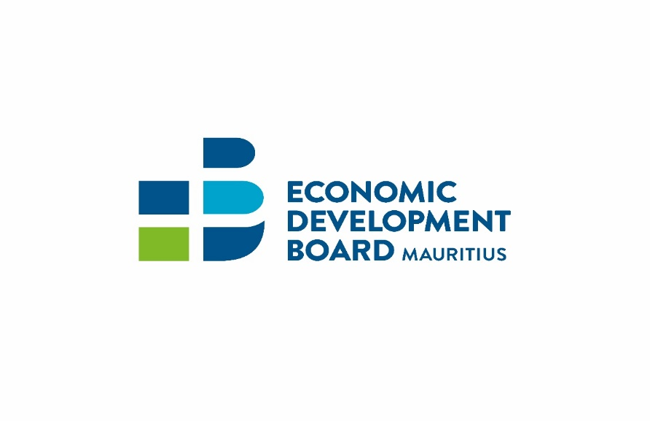

PDS for Senior Living
Guidelines for Buyers

Issue date: May 2021

Contents
Preface 3
part 1: Sale of residential units 4
1.1 BASIS of sale of a residential property 4
1.2 Financing of residential roperty 4
1.3 Application to acquire property under PDS for SeNIOR LIVING 5
1.4 SCREENING OF APPLICATION 5
1.5 Documents to be submitted at the time of application 5
part 2: rent & Leases of residential unit 7
2.1 Rental of residential unit 7
part 3: Sale of life right 8
3.1 Acquisition of life right 8
3.2 Documents to be submitted for acquisition of life right 8
3.3 Termination of life right 8
3.4 maintenance of the scheme 9
part 4: residency in mauritius 10
4.1 residency in Mauritius 10
4.2 Documents to be submitted for residence permit 10
part 5: RESALE of Residential property 11

Preface

This publication contains guidance for non-citizen buyers interested in acquiring a unit in a project under the Property Development Scheme (PDS) relating to senior living. These guidelines are based on provisions of the Economic Development Board 2018 and the Economic Development Board (Property Development Scheme) Regulations 2015 and are designed to provide information and assist in decision-making. They are neither intended to replace the provisions of the laws and should not be construed as one nor should they be interpreted as prescribing an exclusive course of management.

Whilst care has been taken to ensure that the information provided herein is accurate and correct, at the time of publication, users of this publication are advised to seek guidance from the Economic Development Board in case of uncertainty or ambiguity encountered in reading. The Economic Development Board shall, in no circumstances whatsoever, be held liable to any person arising from use of information contained herein.

part 1: Sale of residential units
This section deals with the sale of built-up residential properties including sales made under the provisions of a vente en l’état futur d’achèvement (VEFA).
The following persons may acquire a residential property from a company holder of PDS Certificate for Senior Living:
- a citizen of Mauritius
- a non-citizen
- a member of the Mauritian Diaspora registered under the Mauritian Diaspora Scheme
- a company incorporated or registered under the Companies Act
- a société, where its deed of formation is deposited with the registrar of companies
- a limited partnership under the Limited Partnerships Act
- a trust, where the trusteeship services are provided by a qualified trustee
- a Foundation.

BASIS of sale of a residential property

- A residential property under the PDS for Senior Living may be sold either on the basis of a plan, during the construction phase or when the construction is completed.
- Where the acquisition of an immovable property is made on the basis of a plan or during the construction phase, the contract shall be governed by the provisions of a “vente à terme” or vente en l’état futur d’achèvement (VEFA)”, as the case may be, in accordance with provisions of articles 1601-1 to 1601-45 of the Code Civil Mauricien.

- A sale for future delivery is the contract by which the seller undertakes to deliver the building on its completion, and the buyer undertakes to take delivery of it and to pay the price of it at the date of delivery. The transfer of ownership is achieved by operation of law by the acknowledgement of the completion of the building through an authentic instrument; it is effective retroactively on the day of the sale.

- A sale in a future state of completion is the contract by which a seller transfers at once to the buyer his rights in the ground as well as the ownership of the existing structures. The works to come become the property of the buyer as they proceed; the buyer is bound to pay the price of them as the work proceeds.

- In accordance with the provisions of Article 1601-30 of the Code Civil, the price of a residential unit when sold under “vente en l’état futur d’achèvement” is payable in instalments as the work progresses, as follows:
  - Upon signing of the deed: 25%
  - Upon completion of the foundation works: 10%
  - Upon completion of roofed-in phase: 35%
  - Upon completion: 25%
  - Upon availability of premises: 5%

Financing of residential roperty

- Where a residential property is acquired by a non-citizen or a company whose shareholders are non-citizens or a trust whose beneficiaries are non-citizens or the associates of a société are non-citizens or limited partners of a limited partnership are non-citizens or beneficiaries of a foundation are non-citizens, the payment can be made in US dollars or its equivalent in any other freely convertible foreign currency.

- Where a residential property is acquired by a non-citizen, the investment in the acquisition of that residential property must be financed by the purchaser from funds outside Mauritius and transferred to Mauritius through any reputable bank listed in the Banking Almanach recognized by the Bank of Mauritius.

- Where a loan is contracted in Mauritius currency with a bank in Mauritius, the first 500,000 US dollars must be paid in USD or its equivalent in any other freely convertible foreign currency; and the repayment of the loan must be effected in any freely convertible foreign currency.

Application to acquire property under PDS for SeNIOR LIVING

- A non-citizen, company, société, trust, foundation or limited partnership wishing to acquire property under the scheme shall make an application to the Economic Development Board.

- No application for acquisition of immovable property by non-citizens, companies, société, trusts, foundation or limited partnership will be considered by the Economic Development Board if the above documents have not been duly submitted to the EDB.
- The application should be accompanied by a non-refundable processing fee of 20,000 rupees payable through cheque by the smart city company or smart city developer and drawn to the order of the Economic Development Board.
- An application shall be considered as ready for processing by the EDB at the date by which all the information, particulars and documents have been duly submitted and considered as complete by EDB.

SCREENING OF APPLICATION

The PDS Company for Senior Living shall carry out due diligence exercise through a reputable bank for all applications received prior to submission of same to the Economic Development Board. The PDS Company for Senior Living’s bank shall carry a Know Your Client (KYC) exercise and open a bank account for the client called the “Escrow Account”.
The PDS Company for Senior Living may sign the “Contrat de réservation préliminaire a une vente en etat future d’achevement” for the plot. The potential buyer shall deposit at most 25% of the amount of investment in the acquisition of the property in the bank.

Documents to be submitted at the time of application
In the case of a non-citizen, the following documents must be submitted to the EDB:
- duly authenticated copy of first 5 pages of passport
- letter from the bank certifying the KYC exercise for the client
In the case of Company:
- certificate of incorporation under the Companies Act 2001 or Certificate of registration evidencing the company is registered as a foreign company as may be the case:
- register of shareholders
- duly authenticated copy of first 5 pages of passport of each shareholder
- letter from the bank certifying the KYC exercise for the client
In the case of Société:
- evidence of the Société having a file number with the Registrar of Companies and deed of formation deposited with the Registrar of Companies.
- status of the Société
- duly authenticated copy of first 5 pages of passport of each member
- letter from the bank certifying the KYC exercise for the client
In the case of Limited Partnership:
- partnership agreement
- registration certificate of the Limited Partnership by the Registrar of Companies
- duly authenticated copy of first 5 pages of passport of each limited partner
- letter from the bank certifying the KYC exercise for the client
In the case of Foundation:
- the charter of Foundation
- registration certificate of the Foundation by the Registrar of Companies
- details of the beneficiary, founder, secretary and council
- duly authenticated copy of first 5 pages of passport of each beneficiary
- Letter from the bank certifying the KYC exercise for the client
In the case of Trust:
- The trust deed
- Evidence from the Financial Services Commission that the trustee is a qualified trustee under the Trust Act 2001
- Details of the beneficiary, trustee and settlor
- Letter from the bank certifying the KYC exercise for the client

part 2: rent & Leases of residential unit

Rental of residential unit
- The owner of a residential property under the PDS for Senior Living may offer the property for letting to only retired persons through the following:
- The PDS Company for Senior Living
- A Provider of property management services, designated by the PDS Company

- An eligible retired non-citizen wishing to rent or lease a residential unit under the PDS for Senior Living shall submit an application to the Economic Development Board together with the following documents:
- A non-refundable processing fee of MUR 20,000 payable through cheque by the PDS Company for Senior Living and drawn to the order of the Economic Development Board
- Duly authenticated copy of first 5 pages of passport
- Letter from the bank certifying the KYC exercise for the client
- Rental/Lease agreement between the PDS Company for Senior Living or a provider of property management services designated by the PDS Company
- No authorisation is required for rental/lease to citizens of Mauritius and members of the Mauritian Diaspora.

part 3: Sale of life right

Acquisition of life right

- A person acquiring a life right in respect of a residential property has the right to live in a unit for the rest of his life, free of rent. There is no transfer of property. Ownership is retained by the PDS Company for Senior Living.

- The life right terminates upon death of the occupant or if the occupant decides to terminate the agreement. The occupant (i.e the person who has acquired a life right) cannot leave the property to somebody in his will.

- The occupant (with its heirs, administrators, executor and assigns) may not sell the right whether by way of exchange, donation, testamentary disposition, or as a consequence of intestate succession, dispose of the life rights to any other person. [Refer to article 1717 of the code civil - Le preneur a le droit de sous-louer, et même de céder son bail à un autre, si cette faculté ne lui a pas été interdite.]

Documents to be submitted for acquisition of life right
- An eligible retired non-citizen wishing to acquire a life right must submit the following documents:
- Duly authenticated copy of first 5 pages of passport

- Letter from the bank certifying the KYC exercise for the client
- An agreement between the applicant and the PDS for Senior Living duly endorsed by a Notary Public

No authorisation is required for acquisition of life right by citizens of Mauritius and members of the Mauritian Diaspora.

Termination of life right
- On termination of a life right unit or on death of the occupant, the outgoing occupant or the deceased heir receives an amount of the initial investment mutually agreed between the parties.
- Should the developer elect to submit the said right for re-grant, it will do whatever is reasonably necessary to obtain the highest possible new Occupation Consideration from a new Occupant. The new Occupation Consideration will always be within the sole and absolute discretion of the developer whose decision thereon shall be final and neither the Occupant nor his heirs shall have any claim whatsoever against the PDS Company arising out of it having accepted or fixed any particular amount as the new Occupation Consideration.

- The developer will obtain such valuation within 60 days of the Termination Date. In circumstances envisaged above, in the event of a re-grant, upon payment in full of the new Occupation Consideration which the PDS Company undertakes shall not be more than 12 months after the Termination Date or in the event of the developer electing not to submit for re-grant, then upon the determination of the value of the Life Right, the Occupant, or his heirs, as the case may be shall be paid an amount equivalent to the lesser of:
- the original Occupation Consideration paid by the outgoing occupant less any amounts due to the developer (maintenance levy and others)
or
- the new Occupation Consideration paid by the new Occupant (or valuation) less any amounts due to the developer (maintenance levy and others)

maintenance of the scheme
- The occupant may be required to pay a monthly maintenance levy, frail care levy or fees to the Syndic or any management company appointed by the PDS Company for Senior Living as the case may be.

part 4: residency in mauritius

residency in Mauritius
- Pursuant to Regulations 13(1A) of the Economic Development Board (Property Development Scheme) Regulations 2015, a residence permit under the Immigration Act is granted to the non-citizen who acquires, leases, rents or otherwise acquires the right to live in a residential unit for the rest of his life free of rent, from a PDS Company relating to senior living. The application for residence permit can be submitted in respect of himself and/or his spouse or common law partner.

- There is no minimum investment applicable for the obtention of the Residence Permit.

Documents to be submitted for residence permit
- The following documents must be submitted at time of application for the obtention of the Residence Permit:

Documents | Non-citizen who acquires a residential unit | Non-citizen who leases a residential unit | Non-citizen who acquires the right to live
Duly filled in ‘application form to enter Mauritius” | √ | √ | √
First 5 pages of each applicant/dependent passport | √ | √ | √
Medical Certificate | √ | √ | √
Morality Certificate | √ | √ | √
Birth Certificate | √ | √ | √
Notary certificate certifying the ownership of land | √ | N/A | N/A
Lease agreement | N/A | √ | N/A
Notary certificate certifying the ownership of life right | N/A | N/A | √

- If the applicant is accompanied by dependents (his spouse or common law partner), documentary evidence of relationship, i.e. marriage certificate/certificate de concubinage, copy of the first 5 pages of each dependent’s passport, medical certificate of each dependent and morality certificate of spouse must also be submitted.

part 5: RESALE of Residential property
- The owner of a residential property is allowed to resell or transfer the property or any shares, rights or interest acquired under the scheme.

- Where the owner of a residential property intends to sell or transfer the property, he/she is required within 30 days prior to sale, give notice in writing to the Chief Executive Officer of the EDB. A copy of the notice shall be given to the PDS Company for Senior Living.

- The sale or transfer of the residential property can only be made to:

  - a natural person, whether a citizen of Mauritius, a non-citizen or a member of the Mauritian Diaspora;
  - a company incorporated or registered under the Companies Act;
  - a société, where its deed of formation is deposited with the registrar of companies;
  - a limited partnership under the Limited Partnerships Act;
  - a trust, where the trusteeship services are provided by a qualified trustee; or
  - a Foundation.

- The person acquiring the residential property is required to submit an application as per these guidelines. The application must be accompanied by an attestation of opening a bank account through which money for payment shall be transferred and a non-refundable fee of 20, 000 rupees paid by mode of a cheque drawn to the order of the Economic Development Board.

